Лекционная задача

Условие:

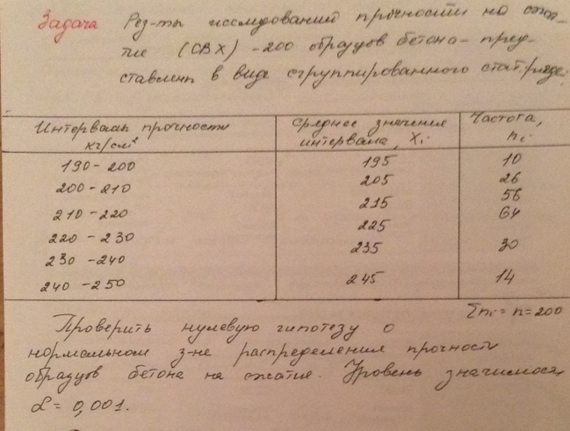

from scipy import stats

intervals = [(190, 200), (200, 210), (210, 220), (220, 230), (230, 240), (240, 250)]

x = [195, 205, 215, 225, 235, 245]

ni = [10, 26, 56, 64, 30, 14]

data = []
for i in range(len(intervals)):
interval = intervals[i]
data.extend([x[i]] * ni[i])

statistic, p_value = stats.shapiro(data)
alpha = 0.001

print("stst:", statistic)
print("meaning:", p_value)

if p_value < alpha:
print("done")
else:
print("not done")

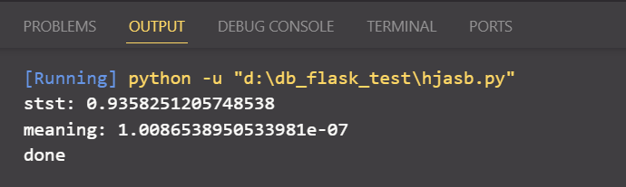

Вывод: не имеют нормального распределения

